**INFR3120** - Web and Script Programming

Assignment 3 - CRUD + Authentication Operation

**Ayman Sohail**

MyStylePlanner

**Project Plan:**

**Project Overview:**

MyStyle Planner is a personal wardrobe + shopping planner web application built for assignment 3. The goal of this assignment is to help users keep track of items they want to buy, prices, categories, and notes all in one place. Instead of saving random screenshots or forgetting the items, users can add, edit, and delete items in a clean and organized way.

**Why I chose MyStylePlanner as my project idea:**

I really love fashion and styling, so I wanted to create a planner that feels aesthetically pleasing while also being functional. This app reflects how I personally organize shopping lists and ideas. The target audience for this app is anyone who shops, builds a wardrobe, or wants a structured way to track wishlist items.

**Features I plan on adding (CRUD Included) :**

* Create new items
* Read/view items in a styled card layout
* update/edit items
* Delete items (with confirmation screen)
* User accounts (signup + signin)

**Technologies/ websites I will use:**

* Node.js
* Express
* MongoDB +Mongoose
* EJS Templating
* CSS
* Bootstrap
* Render for deployment
* Github

**Visual Style Inspiration:**

My design inspiration mainly came from pinterest editorial fashion layouts and deep red magazine inspired tones. I used this photo as my inspiration and created my website in a way that correlates with the image. I chose neutral beige and dark red tones because they felt interesting and matched my moodboard used on the homepage.

Image used for main photo: <https://pin.it/5mMU0WXt0>

Image used for bottom photo: <https://pin.it/2uX5PUqxj>

My main Inspiration

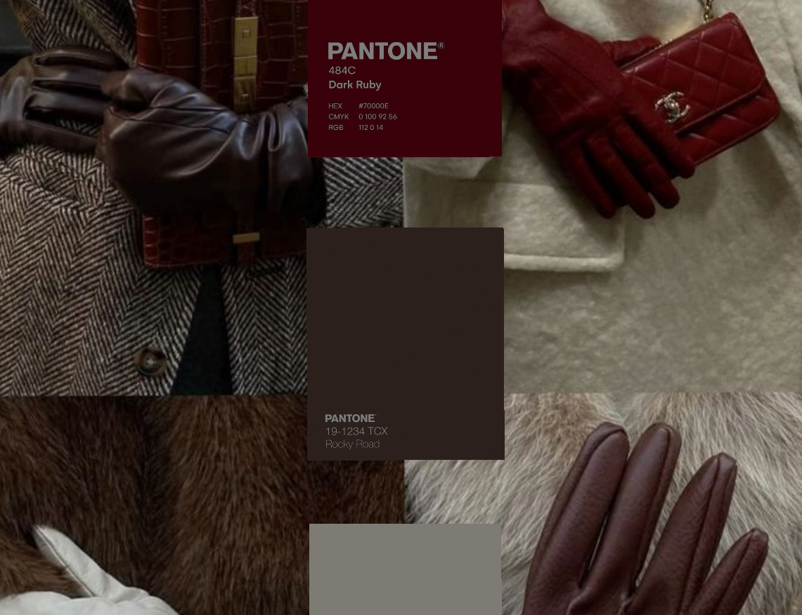 I used these photos on my website as well because they inspired me the most.

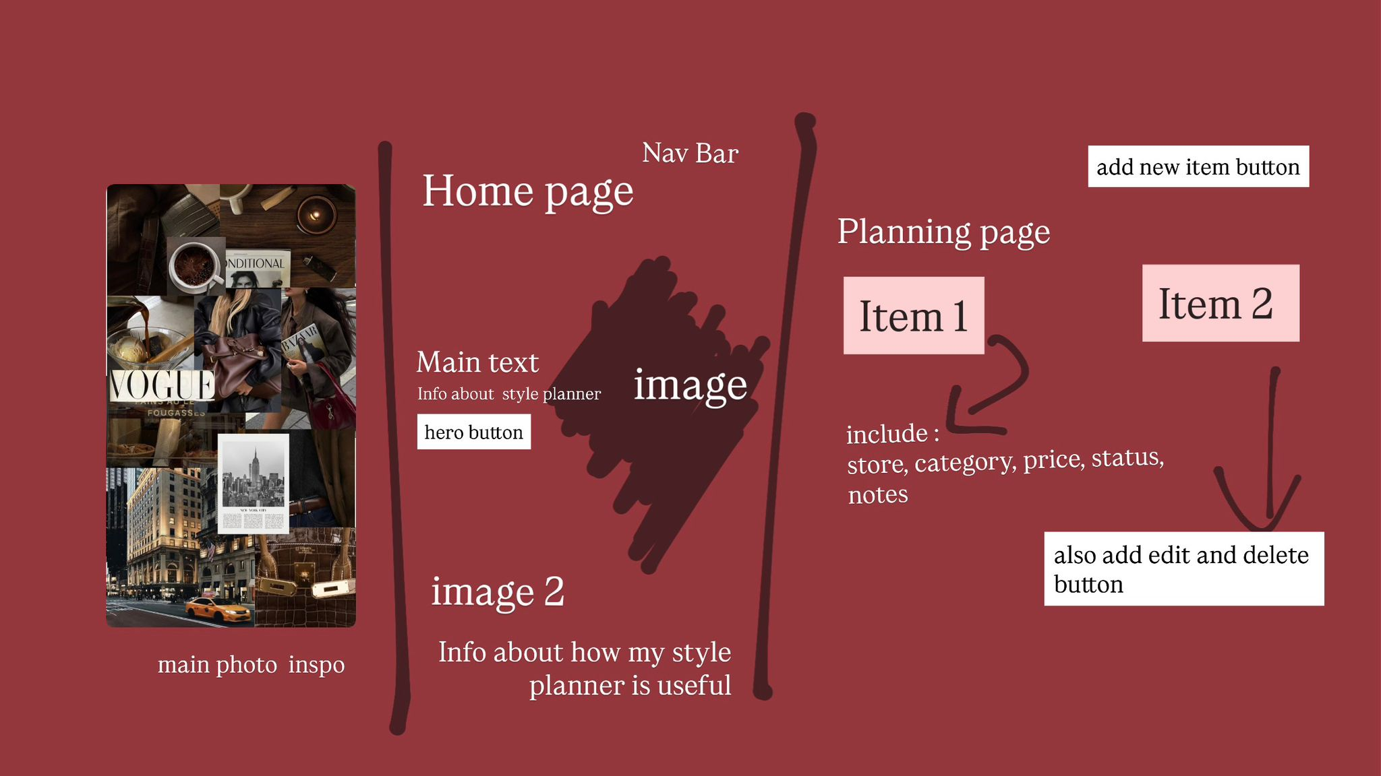

Here is how I planned out the layout of my website.

**How I planned the VS code part of my website:**

* Set up Express + MongoDB
* Create models
* Create routes
* Create views
* Add authentication
* Style everything
* Deploy to Render
* Test all CRUD functions

**Challenges:**

I wanted it to make the signin + signup page in a way that creates a new database for everyone who creates an account but had trouble doing that. I hope to learn from this and try again next time. I also struggled a bit with the CSS spacing but resolved it by adjusting the padding.

I also decided to include pages of my final website on this.

**Final Product:**

**Homepage:**

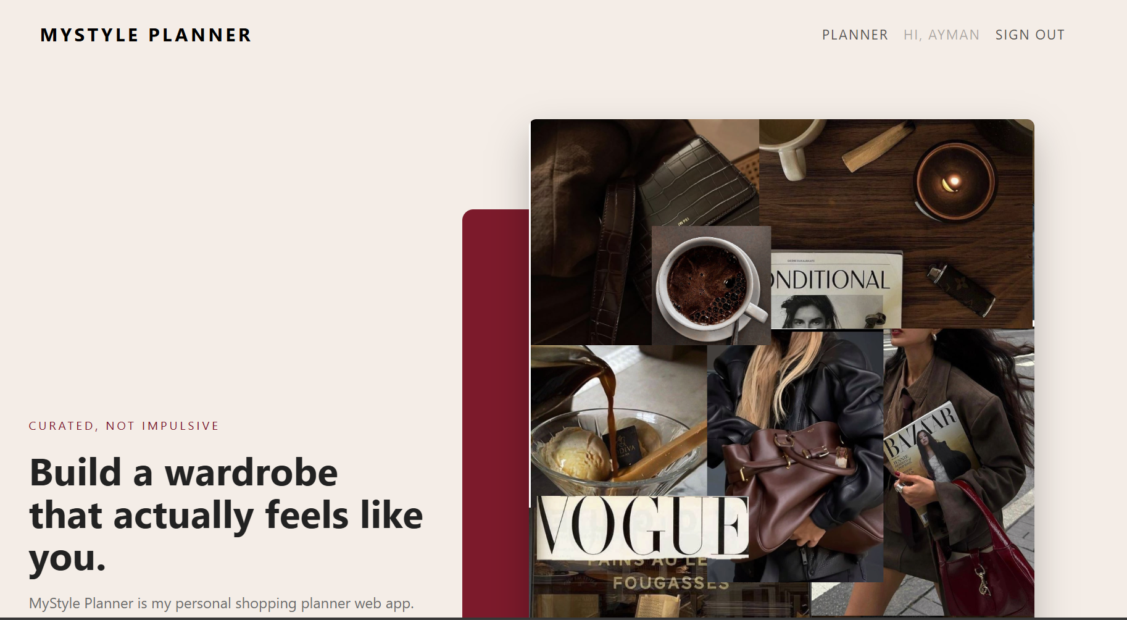

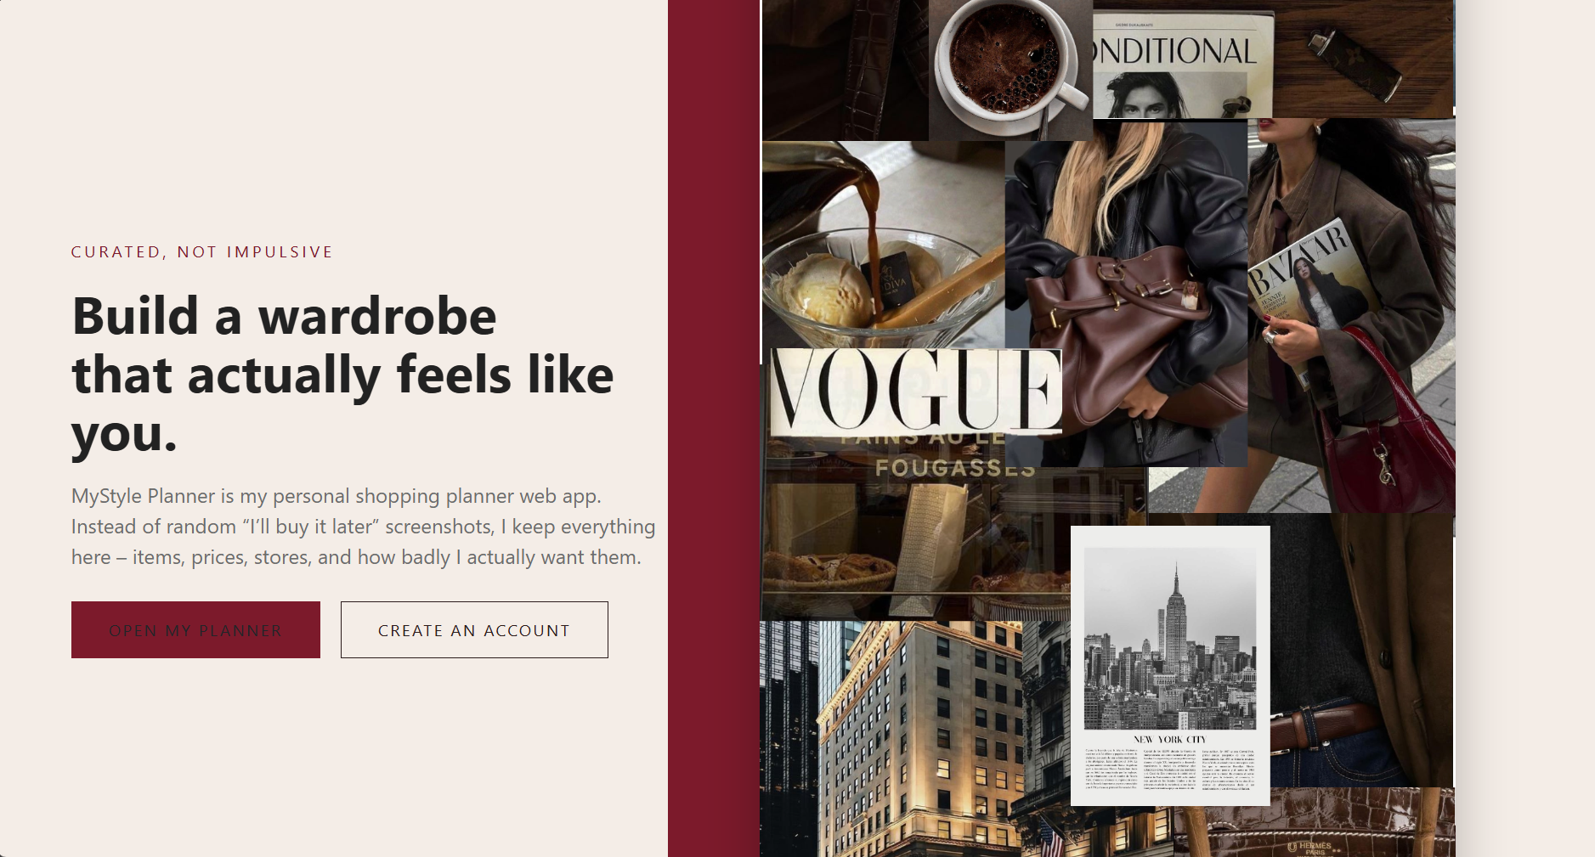

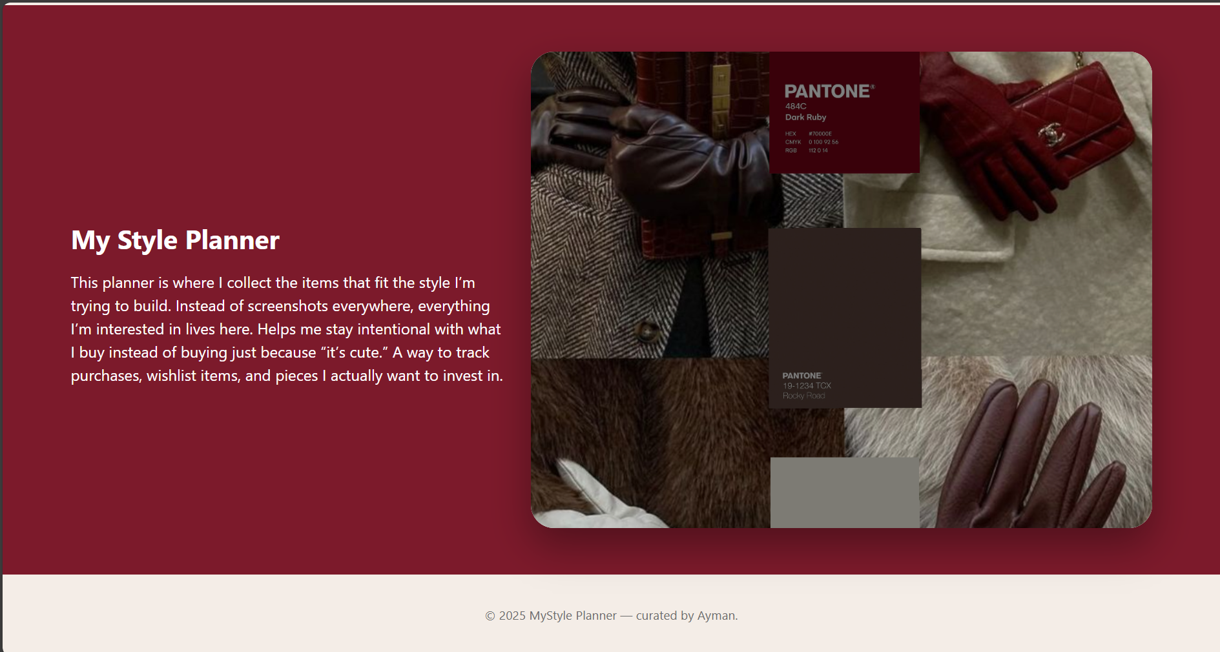

**Planner Page:**

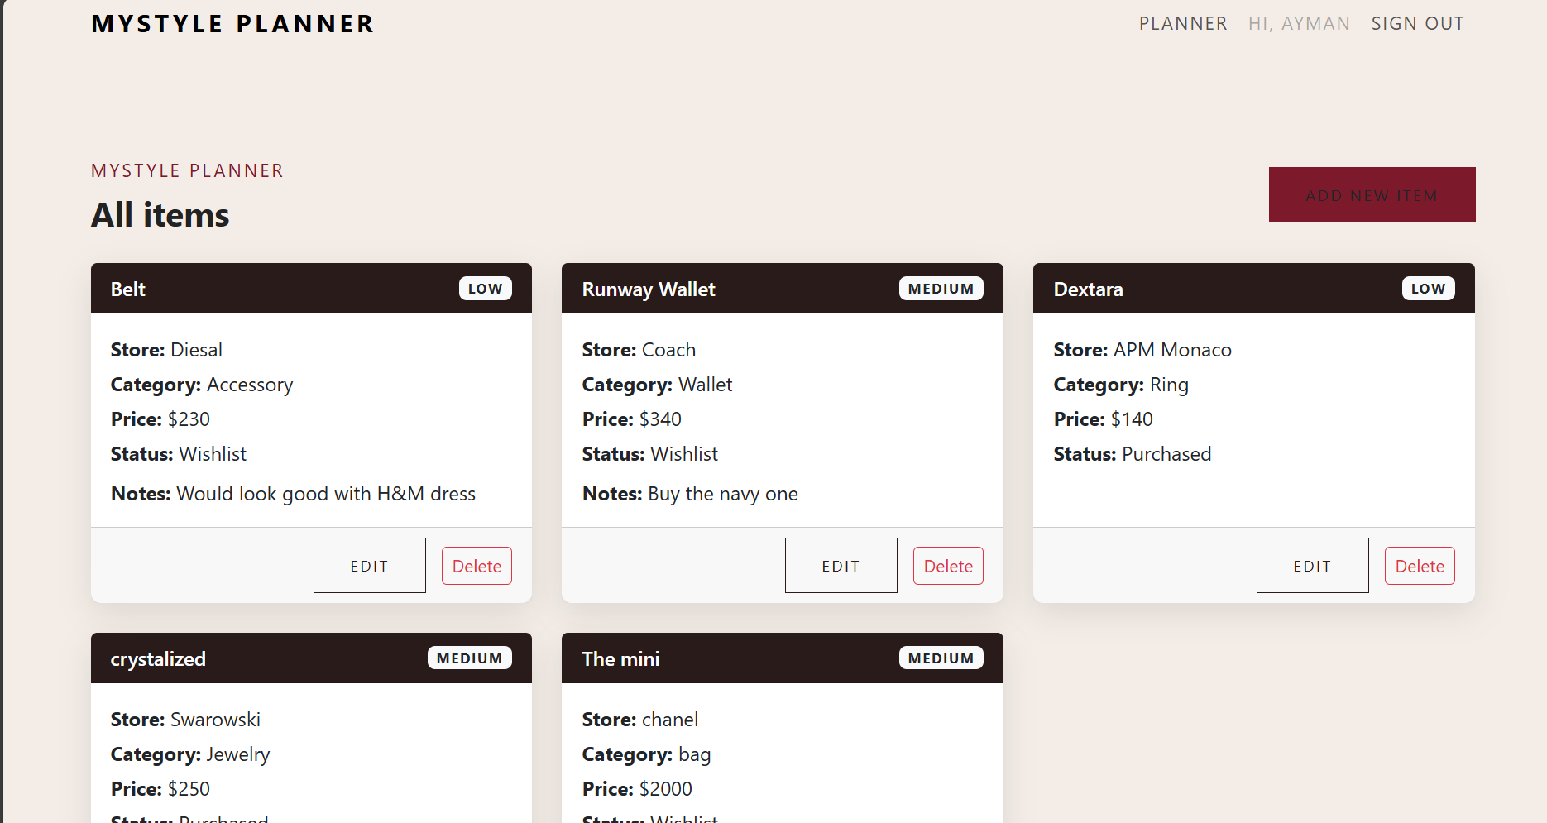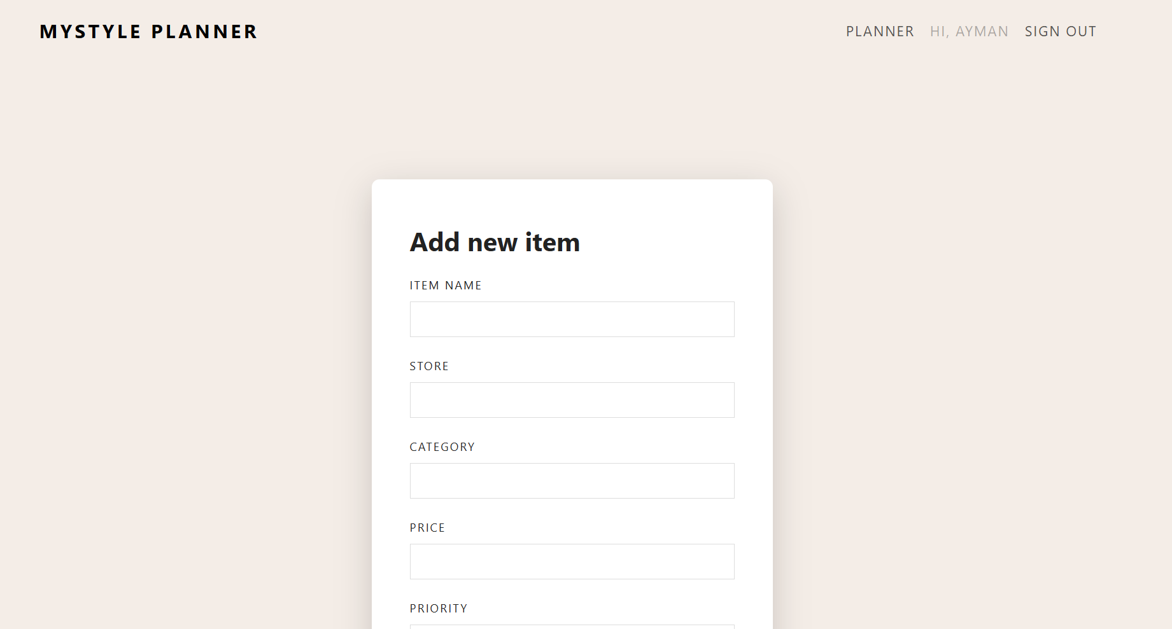

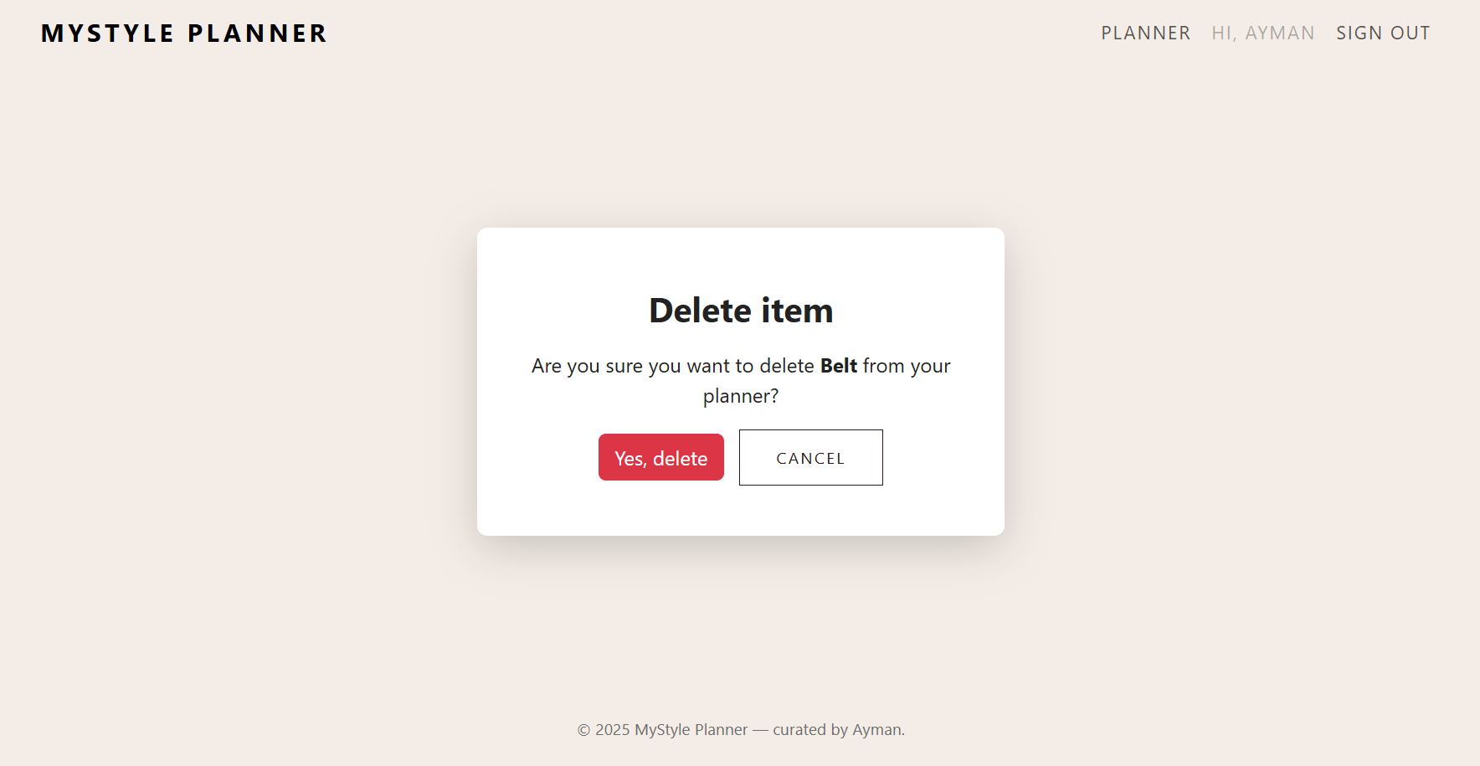

**Create an account, sign page:**

